**data** latdol;

input year month avg end;

DATALINES;

1994 1 0.591 0.582

1994 2 0.577 0.573

1994 3 0.570 0.567

1994 4 0.569 0.563

1994 5 0.565 0.565

1994 6 0.561 0.551

1994 7 0.550 0.554

1994 8 0.549 0.552

1994 9 0.547 0.545

1994 10 0.542 0.537

1994 11 0.543 0.548

1994 12 0.551 0.548

1995 1 0.546 0.543

1995 2 0.541 0.535

1995 3 0.522 0.517

1995 4 0.508 0.508

1995 5 0.514 0.508

1995 6 0.512 0.512

1995 7 0.513 0.515

1995 8 0.529 0.538

1995 9 0.540 0.533

1995 10 0.534 0.534

1995 11 0.535 0.536

1995 12 0.538 0.537

1996 1 0.544 0.549

1996 2 0.546 0.542

1996 3 0.547 0.549

1996 4 0.551 0.552

1996 5 0.553 0.555

1996 6 0.554 0.554

1996 7 0.552 0.548

1996 8 0.548 0.548

1996 9 0.552 0.555

1996 10 0.556 0.554

1996 11 0.550 0.552

1996 12 0.556 0.556

1997 1 0.563 0.573

1997 2 0.578 0.577

1997 3 0.580 0.580

1997 4 0.583 0.586

1997 5 0.578 0.575

1997 6 0.575 0.574

1997 7 0.580 0.589

1997 8 0.590 0.588

1997 9 0.588 0.586

1997 10 0.584 0.578

1997 11 0.581 0.587

1997 12 0.590 0.590

1998 1 0.595 0.592

1998 2 0.592 0.594

1998 3 0.594 0.595

1998 4 0.596 0.594

1998 5 0.595 0.597

1998 6 0.600 0.602

1998 7 0.601 0.599

1998 8 0.603 0.601

1998 9 0.587 0.583

1998 10 0.570 0.568

1998 11 0.574 0.579

1998 12 0.571 0.569

1999 1 0.569 0.574

1999 2 0.579 0.586

1999 3 0.586 0.590

1999 4 0.590 0.591

1999 5 0.593 0.597

1999 6 0.597 0.598

1999 7 0.598 0.588

1999 8 0.586 0.587

1999 9 0.582 0.579

1999 10 0.576 0.577

1999 11 0.581 0.584

1999 12 0.583 0.583

2000 1 0.583 0.588

2000 2 0.594 0.598

2000 3 0.596 0.596

2000 4 0.597 0.602

2000 5 0.610 0.606

2000 6 0.601 0.600

2000 7 0.604 0.606

2000 8 0.611 0.613

2000 9 0.618 0.615

2000 10 0.621 0.624

2000 11 0.624 0.625

2000 12 0.619 0.613

2001 1 0.614 0.619

2001 2 0.618 0.620

2001 3 0.624 0.631

2001 4 0.630 0.628

2001 5 0.632 0.636

2001 6 0.639 0.639

2001 7 0.639 0.635

2001 8 0.628 0.624

2001 9 0.622 0.619

2001 10 0.625 0.626

2001 11 0.630 0.632

2001 12 0.632 0.638

2002 1 0.638 0.644

2002 2 0.642 0.644

2002 3 0.640 0.641

2002 4 0.637 0.630

2002 5 0.627 0.620

2002 6 0.616 0.605

2002 7 0.601 0.604

2002 8 0.605 0.604

2002 9 0.605 0.606

2002 10 0.607 0.606

2002 11 0.601 0.605

2002 12 0.598 0.594

2003 1 0.587 0.581

2003 2 0.583 0.583

2003 3 0.584 0.587

2003 4 0.584 0.581

2003 5 0.570 0.565

2003 6 0.565 0.569

2003 7 0.572 0.571

2003 8 0.577 0.583

2003 9 0.574 0.565

2003 10 0.558 0.557

2003 11 0.558 0.553

2003 12 0.546 0.541

2004 1 0.537 0.539

2004 2 0.535 0.538

2004 3 0.543 0.543

2004 4 0.547 0.553

2004 5 0.551 0.544

2004 6 0.546 0.544

2004 7 0.543 0.548

2004 8 0.546 0.550

2004 9 0.546 0.544

2004 10 0.541 0.534

2004 11 0.529 0.522

2004 12 0.520 0.516

2005 1 0.533 0.539

2005 2 0.540 0.532

2005 3 0.531 0.543

2005 4 0.543 0.543

2005 5 0.552 0.561

2005 6 0.577 0.583

2005 7 0.583 0.582

2005 8 0.571 0.575

2005 9 0.573 0.583

2005 10 0.584 0.579

2005 11 0.595 0.594

2005 12 0.593 0.593

;

**data** latdol2;

set latdol;

date = mdy(month,**1**,year);

format date monyy.;

**proc** **print** data = latdol2;

**proc** **timeplot** data=latdol2;

plot avg;

id date;

**proc** **timeplot** data=latdol2;

plot end;

id date;

**proc** **arima** data=latdol2;

identify var=avg;

**run**;

**Undifferenced ARIMA (0,0,0)**

**proc** **arima** data=latdol2;

identify var=avg;

**run**;

| **Name of Variable = avg** | |
| --- | --- |
| **Mean of Working Series** | 0.576868 |
| **Standard Deviation** | 0.031843 |
| **Number of Observations** | 144 |

| **Autocorrelation Check for White Noise** | | | | | | | | | |
| --- | --- | --- | --- | --- | --- | --- | --- | --- | --- |
| **To Lag** | **Chi-Square** | **DF** | **Pr > ChiSq** | **Autocorrelations** | | | | | |
| **6** | 689.87 | 6 | <.0001 | 0.972 | 0.929 | 0.891 | 0.856 | 0.820 | 0.781 |
| **12** | 1095.22 | 12 | <.0001 | 0.747 | 0.717 | 0.682 | 0.643 | 0.596 | 0.543 |
| **18** | 1231.32 | 18 | <.0001 | 0.492 | 0.440 | 0.387 | 0.336 | 0.287 | 0.236 |
| **24** | 1241.42 | 24 | <.0001 | 0.183 | 0.130 | 0.084 | 0.044 | 0.011 | -0.020 |

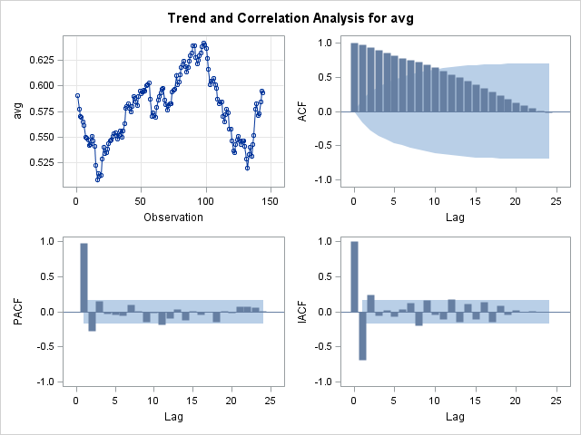

**Differenced once: ARIMA(0,1,0)**

| **Name of Variable = avg** | |
| --- | --- |
| **Period(s) of Differencing** | 1 |
| **Mean of Working Series** | 0.000014 |
| **Standard Deviation** | 0.007351 |
| **Number of Observations** | 143 |
| **Observation(s) eliminated by differencing** | 1 |

| **Autocorrelation Check for White Noise** | | | | | | | | | |
| --- | --- | --- | --- | --- | --- | --- | --- | --- | --- |
| **To Lag** | **Chi-Square** | **DF** | **Pr > ChiSq** | **Autocorrelations** | | | | | |
| **6** | 14.62 | 6 | 0.0235 | 0.300 | -0.053 | -0.035 | 0.036 | 0.038 | -0.058 |
| **12** | 23.94 | 12 | 0.0207 | -0.039 | 0.128 | 0.118 | 0.126 | 0.111 | -0.011 |
| **18** | 25.21 | 18 | 0.1193 | 0.029 | 0.004 | -0.006 | -0.054 | 0.053 | 0.034 |
| **24** | 34.63 | 24 | 0.0741 | -0.049 | -0.140 | -0.107 | -0.095 | -0.071 | -0.089 |

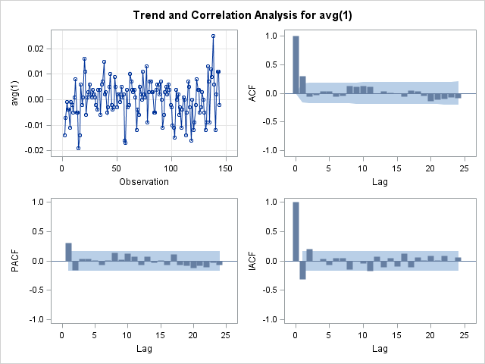

**AR 1,1**

**proc** **arima** data=latdol2;

identify var=avg;

identify var=avg(**1**);

estimate p=**1** noint;

PART B)

**data** latdol;

input year month avg end;

DATALINES;

1994 1 0.591 0.582

1994 2 0.577 0.573

1994 3 0.570 0.567

1994 4 0.569 0.563

1994 5 0.565 0.565

1994 6 0.561 0.551

1994 7 0.550 0.554

1994 8 0.549 0.552

1994 9 0.547 0.545

1994 10 0.542 0.537

1994 11 0.543 0.548

1994 12 0.551 0.548

1995 1 0.546 0.543

1995 2 0.541 0.535

1995 3 0.522 0.517

1995 4 0.508 0.508

1995 5 0.514 0.508

1995 6 0.512 0.512

1995 7 0.513 0.515

1995 8 0.529 0.538

1995 9 0.540 0.533

1995 10 0.534 0.534

1995 11 0.535 0.536

1995 12 0.538 0.537

1996 1 0.544 0.549

1996 2 0.546 0.542

1996 3 0.547 0.549

1996 4 0.551 0.552

1996 5 0.553 0.555

1996 6 0.554 0.554

1996 7 0.552 0.548

1996 8 0.548 0.548

1996 9 0.552 0.555

1996 10 0.556 0.554

1996 11 0.550 0.552

1996 12 0.556 0.556

1997 1 0.563 0.573

1997 2 0.578 0.577

1997 3 0.580 0.580

1997 4 0.583 0.586

1997 5 0.578 0.575

1997 6 0.575 0.574

1997 7 0.580 0.589

1997 8 0.590 0.588

1997 9 0.588 0.586

1997 10 0.584 0.578

1997 11 0.581 0.587

1997 12 0.590 0.590

1998 1 0.595 0.592

1998 2 0.592 0.594

1998 3 0.594 0.595

1998 4 0.596 0.594

1998 5 0.595 0.597

1998 6 0.600 0.602

1998 7 0.601 0.599

1998 8 0.603 0.601

1998 9 0.587 0.583

1998 10 0.570 0.568

1998 11 0.574 0.579

1998 12 0.571 0.569

1999 1 0.569 0.574

1999 2 0.579 0.586

1999 3 0.586 0.590

1999 4 0.590 0.591

1999 5 0.593 0.597

1999 6 0.597 0.598

1999 7 0.598 0.588

1999 8 0.586 0.587

1999 9 0.582 0.579

1999 10 0.576 0.577

1999 11 0.581 0.584

1999 12 0.583 0.583

2000 1 0.583 0.588

2000 2 0.594 0.598

2000 3 0.596 0.596

2000 4 0.597 0.602

2000 5 0.610 0.606

2000 6 0.601 0.600

2000 7 0.604 0.606

2000 8 0.611 0.613

2000 9 0.618 0.615

2000 10 0.621 0.624

2000 11 0.624 0.625

2000 12 0.619 0.613

2001 1 0.614 0.619

2001 2 0.618 0.620

2001 3 0.624 0.631

2001 4 0.630 0.628

2001 5 0.632 0.636

2001 6 0.639 0.639

2001 7 0.639 0.635

2001 8 0.628 0.624

2001 9 0.622 0.619

2001 10 0.625 0.626

2001 11 0.630 0.632

2001 12 0.632 0.638

2002 1 0.638 0.644

2002 2 0.642 0.644

2002 3 0.640 0.641

2002 4 0.637 0.630

2002 5 0.627 0.620

2002 6 0.616 0.605

2002 7 0.601 0.604

2002 8 0.605 0.604

2002 9 0.605 0.606

2002 10 0.607 0.606

2002 11 0.601 0.605

2002 12 0.598 0.594

2003 1 0.587 0.581

2003 2 0.583 0.583

2003 3 0.584 0.587

2003 4 0.584 0.581

2003 5 0.570 0.565

2003 6 0.565 0.569

2003 7 0.572 0.571

2003 8 0.577 0.583

2003 9 0.574 0.565

2003 10 0.558 0.557

2003 11 0.558 0.553

2003 12 0.546 0.541

2004 1 0.537 0.539

2004 2 0.535 0.538

2004 3 0.543 0.543

2004 4 0.547 0.553

2004 5 0.551 0.544

2004 6 0.546 0.544

2004 7 0.543 0.548

2004 8 0.546 0.550

2004 9 0.546 0.544

2004 10 0.541 0.534

2004 11 0.529 0.522

2004 12 0.520 0.516

2005 1 0.533 0.539

2005 2 0.540 0.532

2005 3 0.531 0.543

2005 4 0.543 0.543

2005 5 0.552 0.561

2005 6 0.577 0.583

2005 7 0.583 0.582

2005 8 0.571 0.575

2005 9 0.573 0.583

2005 10 0.584 0.579

2005 11 0.595 0.594

2005 12 0.593 0.593

;

**data** latdol2;

set latdol;

date = mdy(month,**1**,year);

format date monyy.;

**proc** **print** data = latdol2;

**proc** **arima** data=latdol2;

identify var=avg(**1**);

identify var=end(**1**) crosscor=avg(**1**);

**proc** **varmax** data=latdol2;

model avg end / p=**5** dif=(avg(**1**) end(**1**));

output lead=**5**;

**run**;